***MODULE -1***

Ques-1 : What Is Software? What Is Software Engineering?

Answer :

**SOFTWARE**

Software Is Collection of programming code And Documentation.Software,Instructs computer what To Do. In Other Words Software Is A Programme That Instructs The Computer what User Wanted To Get.

For Eg : MS Word, etc.

**SOFTWARE ENGINEERING**

Software Engineering Deals With Design, Development, Testing, Maintenance of Software Applications. Software Engineers Create Web Applications, mobile Apps, Robots, And Network Systems.

Ques-2 : Explain The Types Of Software?

Answer : Software Generally Refers To Programme. Software Are Mainly Classified Into 7 Categories : System Software, Application Software, Engineering Software, Embedded Software, Product Line Software, Web Application, And Artificial Intelligence Software.

Ques-3 : What Is SDLC ? Explain Each Phase Of SDLC?

Answer : A Structured Process That Enables The Production Of High-Quality, Low Cost Software, In Minimum Time.

**PHASES OF SDLC**

* Planning
* Analysis
* Design
* Implementation
* Testing
* Maintenance

Ques-4 : What Is DFD ? Create A DFD Diagram On Flipcart ?

Answer : DFD means Data Flow Daigram .Data Flow Daigram Provides A Graphical Representation Of Data Flow Of A System That Can be Understood By Users. DFD Is Not A Flowchart.

Note : Daigram is on next page

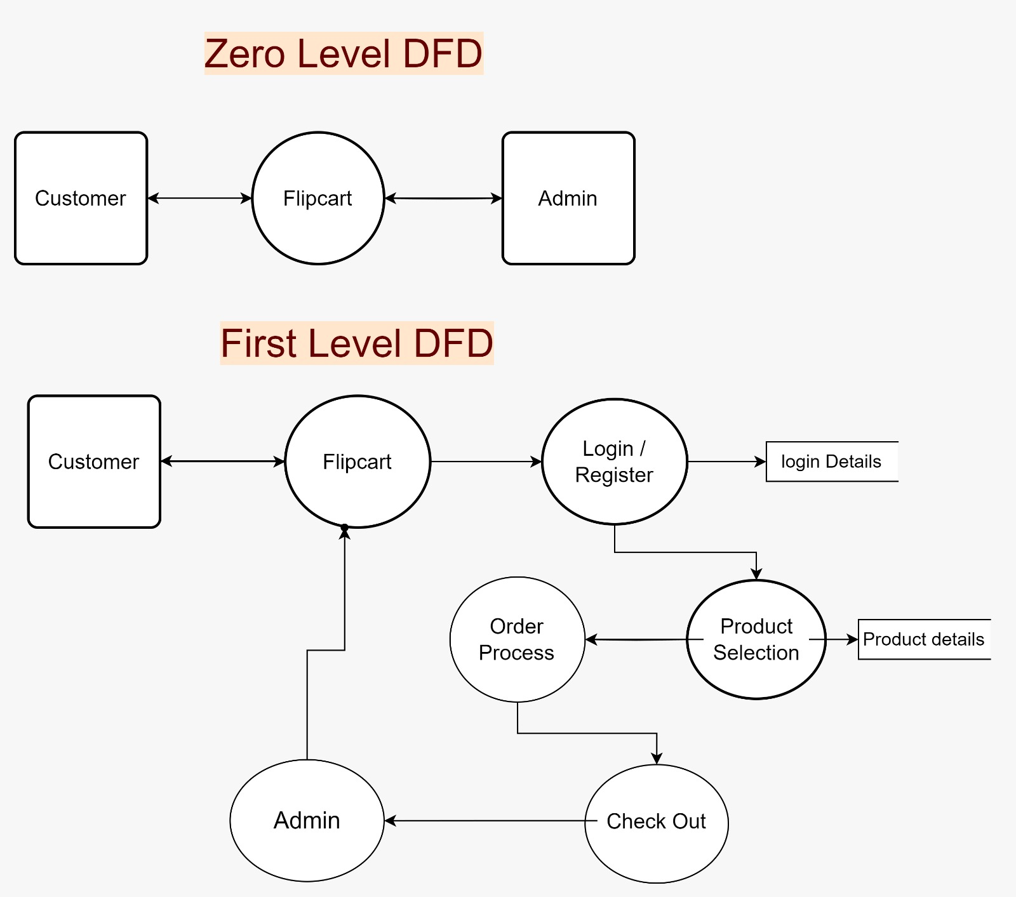

Ques-5 : What Is Flowchart ? Create A Flowchart To Make Addition Of Two Numbers.

Answer : A Daigram That Shows The Connection Between Different Stages Of A Process Or Parts Of System. It Is A Graphical Representation.

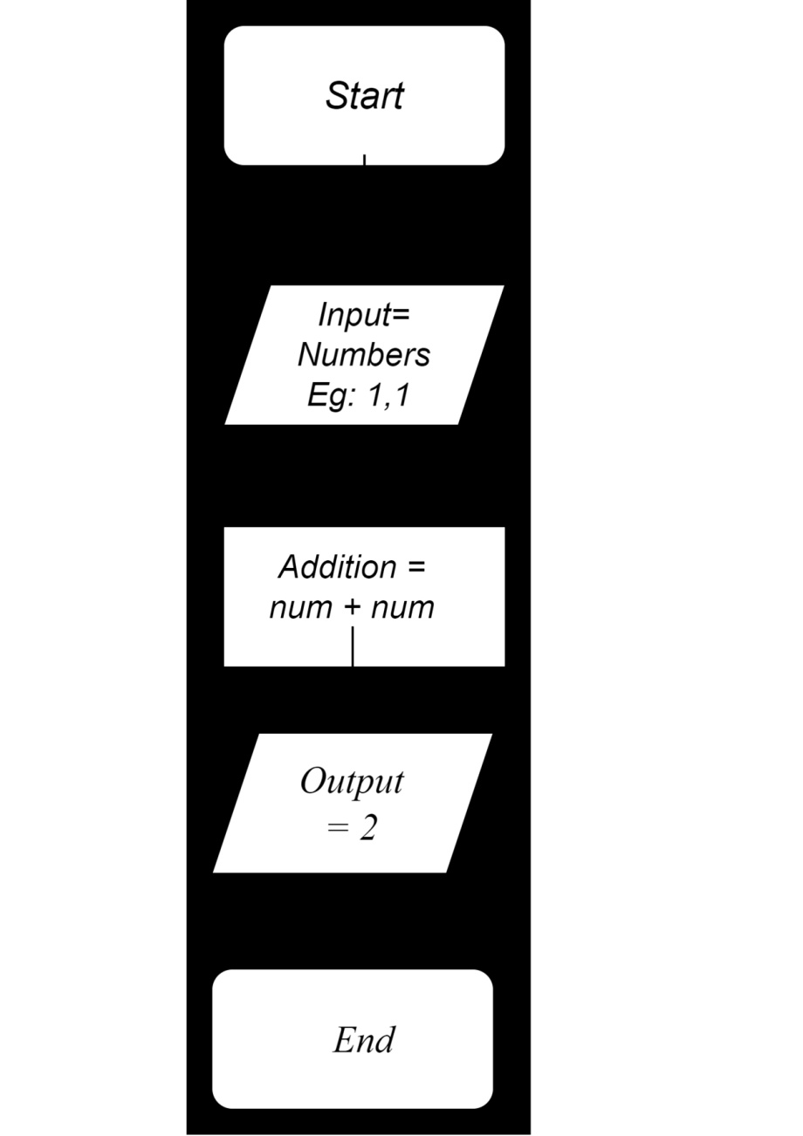

Ques-5 : What Is Use Case Daigram ? Create AUse Case On Bill Payment On Paytm ?

Answer : A Use Case Daigram Is A Vital Tool In System Daigram, It Provides Visual Representation.Use Case Daigrams Are Blueprints Of Your System.

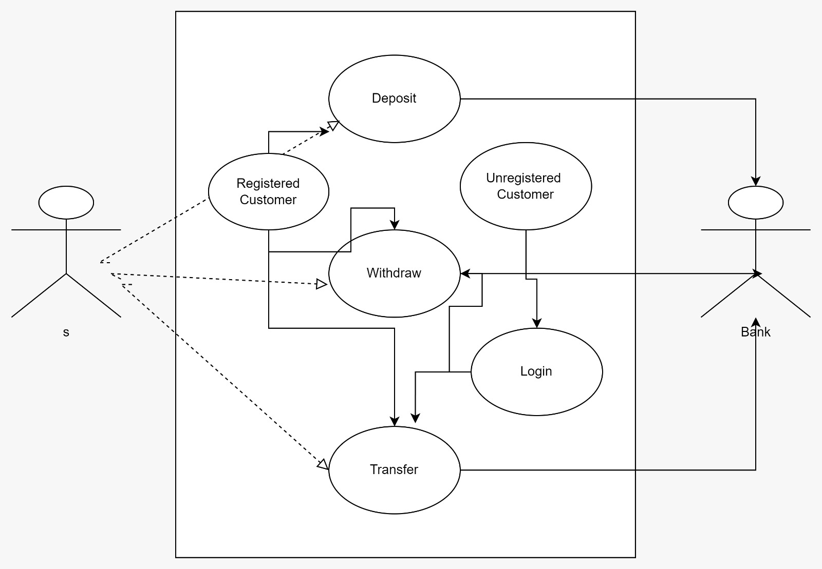

***….END….***